CMPE314 – SOFTWARE ENGINEERING
Lab 4 Solution: Sequence Diagrams
Project: FitTrack – Personal Fitness Companion
Group 3/1: Tawfig Malik (22115813), Lahsen Aittjiou (22118897), Hassan Eihab HassanAli (22211935)

Part 1 – Library Kiosk Return Book sequence
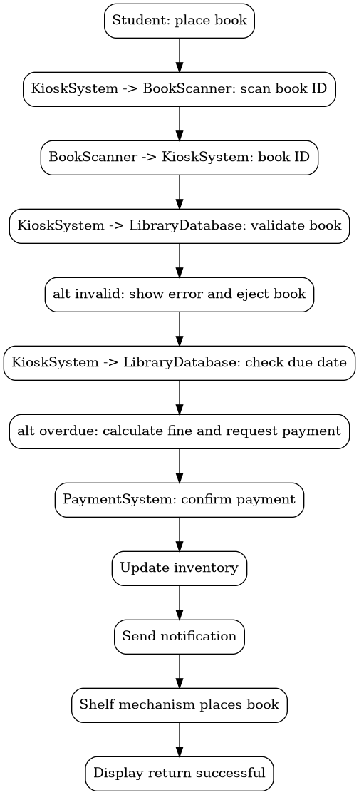
Normal flow: the student places the book, the kiosk scans and validates it, updates inventory, sends a notification, shelves the book, and displays success. Alternative flows handle invalid books, scanner failure, and overdue fines.

Part 2 – FitTrack sequence diagram: Log Workout
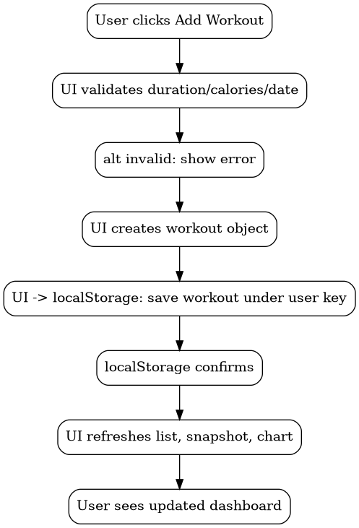
The UI validates input before saving. If values are negative or missing, an error is shown. If valid, the workout is saved in localStorage under the current user key and the dashboard/chart refreshes.
function addWorkout() {
const type = workoutType.value;
const duration = Number(workoutDuration.value);
const calories = Number(workoutCalories.value);
const date = workoutDate.value;
if (!type || duration < 0 || calories < 0 || !date) {
alert("Please enter valid workout data");
return;
}
const workouts = JSON.parse(localStorage.getItem(`workouts_${currentUser}`)) || [];
workouts.push({ id: Date.now(), type, duration, calories, date });
localStorage.setItem(`workouts_${currentUser}`, JSON.stringify(workouts));
refreshDashboard();
}

